**Something Fruity User Guide**

Welcome to the Something Fruity app.

1. Update appsettings file under the connections string section. Update the connection string to the one that corresponds with the user SQL database.
2. User must run migration.

Add-migration <name>

Update-database.

**How to use the application:**

1. Registration

* User has to enter an email address in a valid format, and their login password twice to create user account.
* 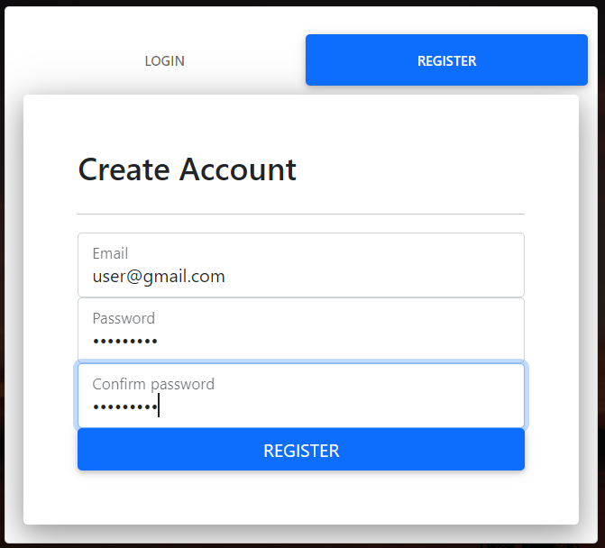

1. Login

* Enter valid login credentials to gain access to the system.
* 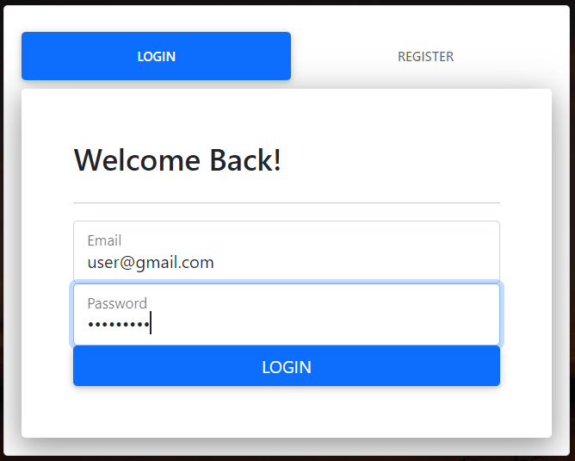

1. Dashboard

* 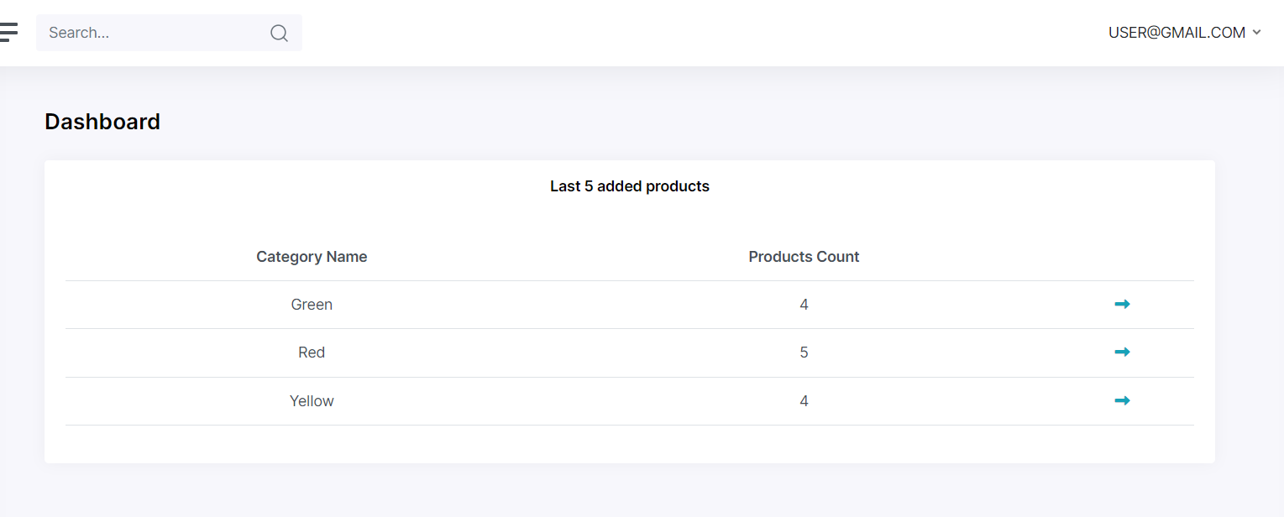
* Arrow drilling down to the products belonging to the category.

1. Categories

* Create a new category with a unique name, user needs to give category a unique code containing 3 alphabet letters and three numeric characters e.g., ABC123. The user will be unable to successfully create a category without carefully following these instructions. Finally, the user can tick the tick box to state if the category is active or not active.
* A screenshot of a computer

  Description automatically generated
* The user will be able to edit the category after creation for any modifications required.

1. Products

* The user can view the list of existing products. The user can sort, and filter based on specific columns.
* 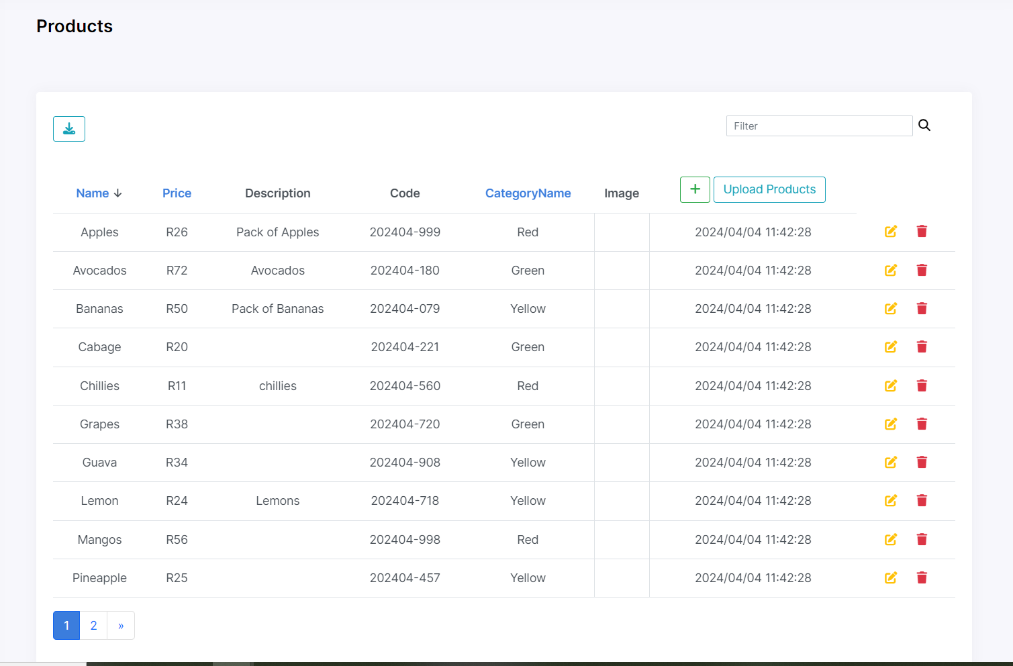
* The user is also able to create an individual product as in the image below:
* 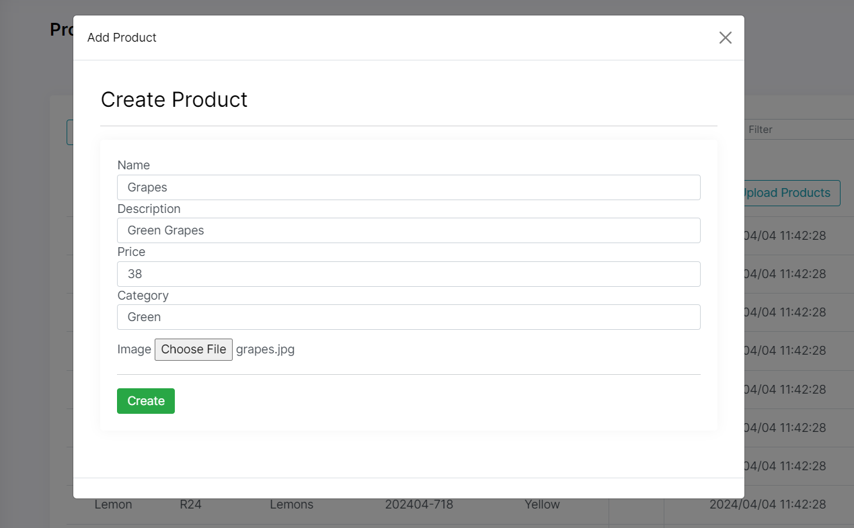
* The system also creates a unique code for each product created into the system.
* The user is only able to select an already existing category from the drop down for the new product to be registered under.
* The user is also able to create bulk products by uploading an excel file with details of the new products. Any issue found on the file or any product with a category name not already existing on the system and the entire upload will be aborted. The user will have to make the necessary changes and re-upload the file.
* A screenshot of a computer

  Description automatically generated
* The user can find a template upload file under the following directory: SomethingFruity/wwwroot/Uploads/ProductsTemplate.xlsx
* To use this file, the user will first need to create 3 categories (Red, Green, Yellow), and the upload will work successfully.
* A screenshot of a computer

  Description automatically generated
* The user can update the details and add an image of an existing product.
* 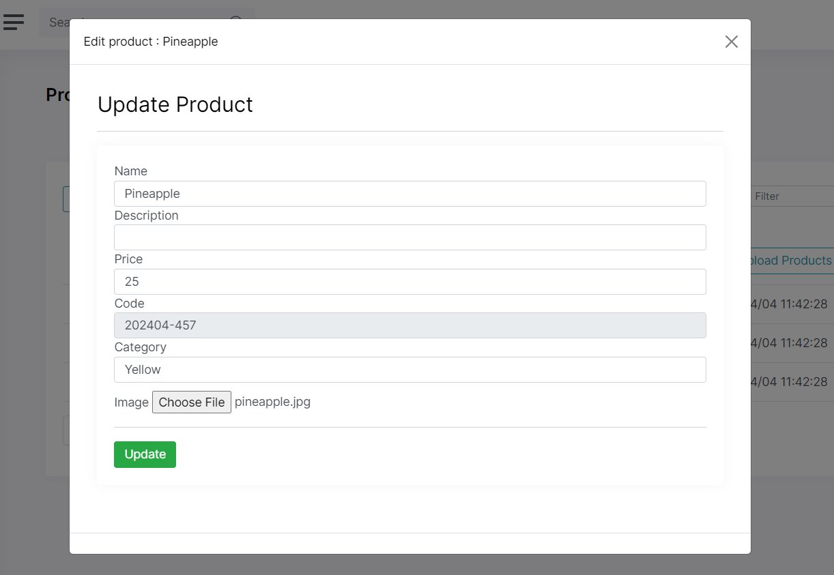
* The user can also remove any existing product.
* 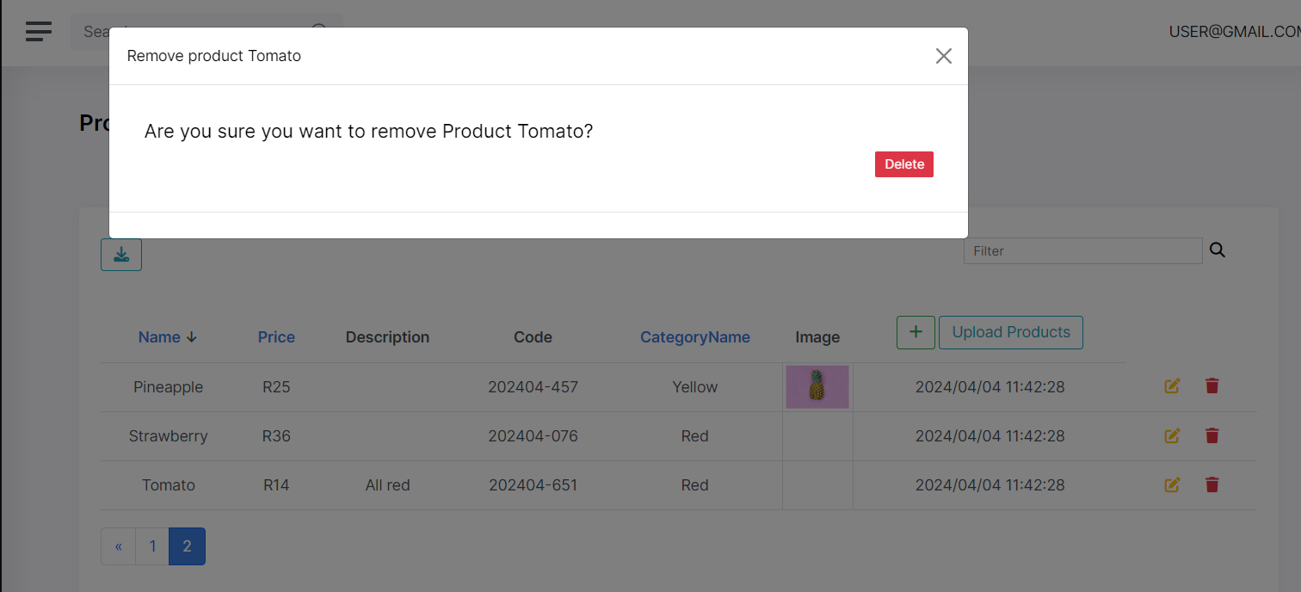
* The user can also export the list of products to CSV
* 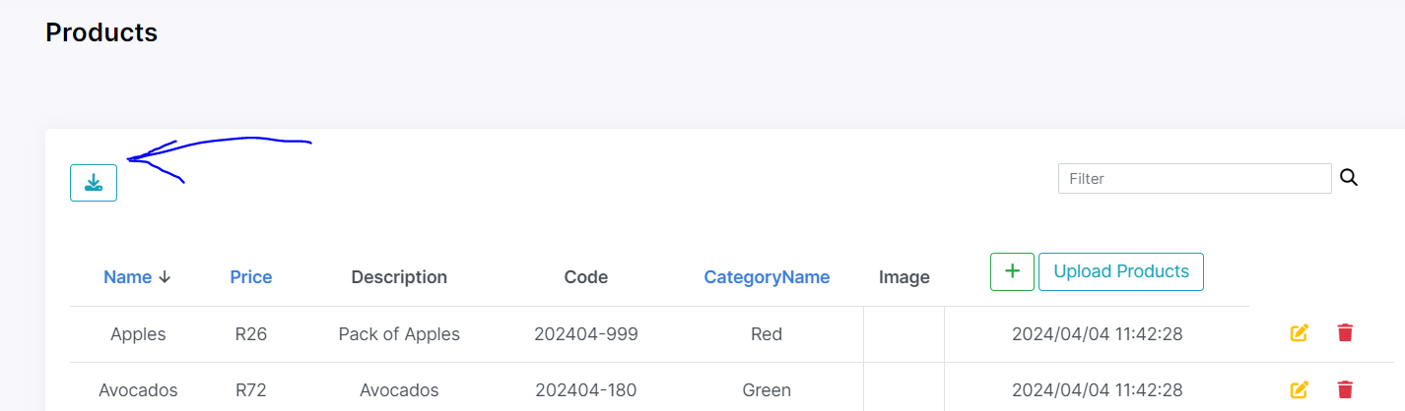

1. Logging Out

* The user can logout and will be required to log can in to access the system.
* 